

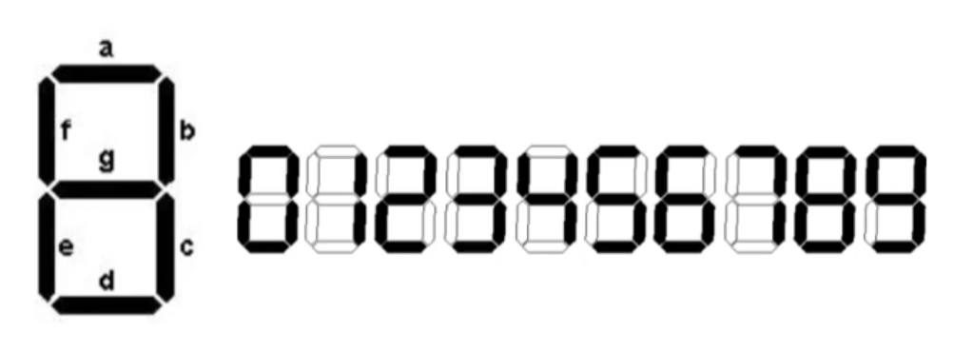

| b1 | b2 | b3 | b4 | a | b | c | d | e | f | g |
| --- | --- | --- | --- | --- | --- | --- | --- | --- | --- | --- |
| 1 | 1 | 1 | 1 | 0 | 0 | 0 | 0 | 0 | 0 | 0 |
| 1 | 1 | 1 | 0 | 0 | 0 | 0 | 0 | 0 | 0 | 0 |
| 1 | 1 | 0 | 1 | 0 | 0 | 0 | 0 | 0 | 0 | 0 |
| 1 | 1 | 0 | 0 | 0 | 0 | 0 | 0 | 0 | 0 | 0 |
| 1 | 0 | 1 | 1 | 0 | 0 | 0 | 0 | 0 | 0 | 0 |
| 1 | 0 | 1 | 0 | 0 | 0 | 0 | 0 | 0 | 0 | 0 |
| 1 | 0 | 0 | 1 | 1 | 1 | 1 | 1 | 0 | 1 | 1 |
| 1 | 0 | 0 | 0 | 1 | 1 | 1 | 1 | 1 | 1 | 1 |
| 0 | 1 | 1 | 1 | 1 | 1 | 1 | 0 | 0 | 0 | 0 |
| 0 | 1 | 1 | 0 | 1 | 0 | 1 | 1 | 1 | 1 | 1 |
| 0 | 1 | 0 | 1 | 1 | 0 | 1 | 1 | 0 | 1 | 1 |
| 0 | 1 | 0 | 0 | 0 | 1 | 1 | 0 | 0 | 1 | 1 |
| 0 | 0 | 1 | 1 | 1 | 1 | 1 | 1 | 0 | 0 | 1 |
| 0 | 0 | 1 | 0 | 1 | 1 | 0 | 1 | 1 | 0 | 1 |
| 0 | 0 | 0 | 1 | 0 | 1 | 1 | 0 | 0 | 0 | 0 |
| 0 | 0 | 0 | 0 | 1 | 1 | 1 | 1 | 1 | 1 | 0 |

|  |  |  |  |  |
| --- | --- | --- | --- | --- |
|  |  |  |  |  |
|  |  |  |  |  |
|  |  |  |  |  |
|  |  |  |  |  |